Citizens Advice in Dorset: Universal Credit - Snapshot
May 2018

Citizens Advice in Dorset comprises the seven local Citizens Advice offices covering Bournemouth, Poole and the county of Dorset. Citizens Advice provides free, confidential and impartial information, advice and support across a range of subjects, with welfare benefits and debt issues making up half of all enquiries. We record and analyse data allowing us to track trends and issues. Given the major changes introduced by Universal Credit we are well placed to assess the impact of the new benefit on our residents. We are also keen to work with partners to support the roll-out. This ‘snapshot’ presents some of our initial findings.
Number of Clients with Universal Credit [UC] Issues
Across Bournemouth, Dorset and Poole local Citizens Advice offices were contacted by 1,108 clients with 2,110 issues relating to UC in the period October 2017 to March 2018. The top 3 UC issues recorded were: the initial claim (n1023, 48%), housing elements (n297, 14%) and universal support (n135, 6%). There were 96 more detailed ‘evidence forms’ submitted during this period which give further insight into the specific issues clients are facing.
The chart opposite shows the substantial increase in issues from January to March 2018 when the full service roll out had started in all areas. In these months local Citizens Advice saw 928 clients with 1,832 issues. 70 detailed ‘evidence forms’ were submitted from January to March, 73% of the overall total since the rollout of UC in October 2017.
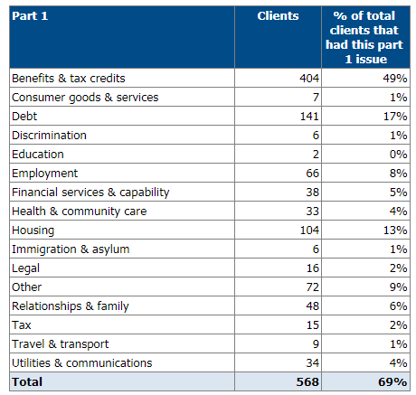
In March 2018 12% (323) of all clients (2,676) contacting local Citizens Advice had an issue relating to UC. In terms of issues during this month UC issues were the third highest issue clients presented with, after Benefits and Tax Credits and Debt. 37 (11%) of the 323 were in some form of paid employment.

Clients with UC Issues presenting with other issues
Of those clients who presented with UC issues from January to March 2018, 568 also pesented with other issues (see chart opposite). Advice regarding other Benefits and Tax Credits, Housing and Debt were the most common additional issues for clients alongside the main issue relating to UC.

Other Related Issues – Debt
There has been a dramatic rise in debt-related issues in the period October 2017 to March 2018 compared with the same period for the two previous years. From October 2017 to March 2018 all local Citizens Advice dealt with 6,135 issues relating to debt representing a 17% increase compared to the same period 2016-2017. If we just look at the data from January to March 2018 there is a 22% increase in debt-related issues compared with the same quarter for the previous year. This is a worrying trend and one which we will continue to monitor in the coming months.

Demographics of Clients with UC Issues
Below is a summary of the demographics of those clients who approach local Citizens Advice across the area with a UC issue.
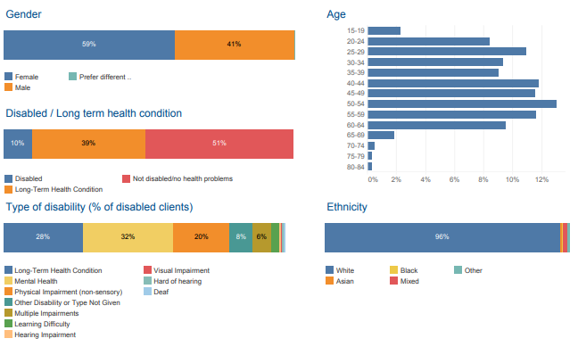
DWP Statistics compared with local Citizens Advice
It was useful comparing the numbers of UC clients Citizens Advice has seen in relation to the numbers of households actually claiming UC using DWP statistics. For this report we looked at figures for those claiming UC up to December 2017. Across three local Citizens Advice initial analysis suggests that of those claiming UC, up to 1 in 5 sought Citizens Advice assistance with their claim.
For example in the West Dorset local authority area the total number of housholds on Universal Credit as at December 2017 was 429 and the Citizens Advice offices covering that area saw 88 clients (21%) with 132 issues relating. We intend to do further comparisons of Citizens Advice and DWP data in the future.

Specific Issues of Concern
Nationally Citizens Advice have conducted a series of public campaigns to address some of the issues faced on a national scale including -
- Remove the 7 waiting days at the start of a claim. Achieved from February 2018
- Make sure everyone moving to UC is told they can get an Advance Payment. Guidance issued to JC.
- Make the UC helpline free of charge. Achieved from November 2017.
- Pause the roll out of UC. Slowed down the rate of new areas moving on to UC although a more significant pause should be considered.
- Give those who need it a payment within 2 weeks, which they do not need to pay back. In progress.
- Improve people’s financial incentives to work. In progress.
- Ensure people have access to a minimum standard of support to help them access and adapt to UC. In progress.
- Make UC less complicated. Announced new claims for the old version of UC - live service - will cease on 31 December.
Local Citizens Advice have supported these campaigns. Below are some of the specific issues our clients are facing since the roll out of UC started across Bournemouth, Dorset and Poole.

Issue | Suggested Resolution
Access
Digital access for those without access to a computer or the skills to use a computer | Publish the minimum standard of support claimants can expect. Local
Access for those who will never be able to use a digital service due to a disability or long term health condition | Publish the provision of Assisted Digital and the support claimants can expect both with their initial claim and on-going support. Local
Difficulties travelling for frequent visits to Job Centres | Rationalise the numbers of visits needed and explore alternative means of communication i.e. Skype. Local
A significant number of clients unable to navigate the online verification process, even with support | The UC online verification process needs to be addressed as a matter of urgency and greater flexibility on the evidence required. Local and National
Process
Delays between submitting the initial claim and first appointment at the Job Centre | Local Job Centres need to address the scheduling of first appointments as a matter of urgency. Local
Delays verifying housing costs within the assessment period | Clearer guidance for DWP regarding what evidence is acceptable. Local
Levels of deduction from UC in relation to Advance Payments, overpayments and certain debts. These are often too high and leave people with little actual income to live on. | UC deductions should be realistic and affordable for claimants. Local  The timescale for repayments should be scheduled up to 36 months rather than 12. National
HMRC delays putting PAYE earning data on the UC system means clients input data via journal which if inaccurate, can affect payments | Improved timeliness and transfer of data by HMRC. National
Training and Development
Inaccurate information from DWP staff particularly in relation to the new style ESA/JSA based on their contribution record. Clients use a paper form for these. | Training and information needs to be provided on this specific issue to relevant staff. Local
Unusual housing costs cause particular problems and confusion for example specified housing costs | Training and information needs to be provided on this specific issue to relevant staff. Local

Conclusion
This report gives a useful snapshot regarding the impact of Universal Credit locally. Citizens Advice ​support ​the ​principles underpinning ​Universal ​Credit ​- ​to ​simplify ​the ​benefit ​system ​and ​make ​work ​pay ​- and ​believe ​it ​has ​the ​potential ​to ​bring ​about ​much ​needed ​positive ​changes ​to ​our benefit ​system. ​However, ​initial ​evidence ​suggests ​ ​changes ​are ​required ​if ​it is ​to ​achieve ​its ​aims.
We will be continuing to analyse data and case studies going forward, with a view to producing a fuller report on the impact of UC and the issues it is creating across the area in the summer.
For further information contact Caroline Buxton, Executive Manager, Citizens Advice in Dorset caroline@caidorset.org.uk
Appendix: Sample cases from our team of Income Maximisation caseworkers
ONE: This client is widowed with a teenage child, not working due to ill health. She received some benefits already and lived in a housing association property. She was helped with a benefits check which showed she would be eligible for UC plus Council Tax Reduction. The rules for claiming UC and maintaining the claim were explained. She decided to make the claim and was helped to do this, which included setting her up with the required on-line log-in information.

TWO: The client was in urgent need of a UC advance payment, but had been unable to get one due to problems with verifying his identity. He attended three ID interviews: At the first interview he was unable to provide sufficient ID. At the second he was finally able to verify his ID, but quickly lost his PSN number and was then told he had to verify his ID again. The frustration this situation caused meant the third interview did not go well, and was terminated, so his claim was not processed. As a result the client has taken out a social fund loan and been referred to the food bank.

THREE: The client was unable to make her commitment meeting so had to re-book, and the meeting was re-scheduled for after the date of her first payment. The UC helpline informed the client that payment will be blocked because she has not attended a commitment meeting. At the time, she thought she could manage as she believed her Employment & Support Allowance award was contribution-based and would continue. However the ESA award stopped, leaving her with no income. Before ESA stopped, she was keeping up with household bills but was now likely to fall into rent arrears and need a food bank referral.
FOUR: A client who had recently separated was not named on the tenancy agreement. The Jobcentre would not therefore accept her as liable for the rent even though she was paying it, and due to arrears was facing re-possession proceedings. The adviser asked for a Mandatory Reconsideration and provided a letter to show that the client was liable for the rent; this was accepted and full rent was then covered. In addition this client did not have internet access and relied on getting to a friend’s house to go on-line, so there was a danger of everything taking too long to get resolved.
FIVE: Client was a single male recently released from prison and living at a Probation Hostel under a licence. He was offered a job 20 miles away but had to sign in every day at the hostel at 1pm so could not take this up. He was helped to claim UC and Housing Benefit for the accommodation, and a letter was written to Probation to ask if the licence conditions could be amended.
SIX: The client in his early 60s was about to go into hospital for cancer treatment. He was receiving Sick Pay from work but was worried about paying his rent. The adviser helped start a UC claim but discovered he could not get an interview at the Jobcentre before he went into hospital. The adviser managed to ring the Jobcentre’s Health & Disability lead and arranged an earlier one. This also meant the DWP could be made aware he would be out of action for a period of time and might not respond to work coach queries (failure to do so can lead to claims being stopped). He was going to have to apply for Council Tax Reduction as well, but that can be done later, as it can be backdated to the date of the UC claim.

